

|  |
| --- |
| **ACME Inc. Network layout and Security analysis**  Mapping out the ACME Inc. Network, its associated IP address ranges, and its subnets, followed by several security tests and vulnerability assessments.  **Mikolaj Mroz**  CMP314: Computer Networking 2  BSc Ethical Hacking Year 3  2021/2022 |

**Contents**

1 Introduction 1

Background 1

Aim 1

2 Network Mapping 2

Network Mapping Methodology 2

Subnet Table 2

Network Diagram 3

Network Mapping Process 3

Determining Kali interface information 3

Scanning for hosts with Netdiscover 4

Scanning for hosts with Nmap 4

Password Cracking with Hydra 5

Gaining access to the routers with Telnet 5

“Show” Command Output Analysis 6

The 192.168.0.0/24 Network 7

The 172.16.221.0/24 Network 9

The 13.13.13.0/24 Network 10

Beyond the Firewall (192.168.0.234) 10

3 Network Security 14

Vulnerability Testing Methodology 14

Tools 15

Network Protocol Testing 15

Network Protocol Traffic Capture 15

Network Protocol Cryptographic Analysis 15

Unknown Protocol Decoding 16

Server OS Testing 16

DNS Interrogation 16

Port Scanning 16

SNMP Enumeration 17

Unauthenticated Vulnerability Scanning 17

Functional Analysis 19

Default Configuration Testing 19

Authentication and Default Credentials Testing 19

Authorization Testing 20

Identify Attack Avenues 20

Further Vulnerability Exploitation 21

Creating SSH tunnels 21

SSH Proxychains 22

Accessing the NFS mount 22

Shellshock 23

RPC Exploits 23

4 Conclusion 25

Countermeasures 25

Plaintext Logins through Telnet 25

Default Credentials 25

Open Ports 25

Simple Passwords 25

SSH 25

Shellshock 25

NFS 25

HTTP Headers 26

Default Files 26

Final Conclusion 26

References 28

Appendices 30

Appendix 1 - Output 30

1A - Empty results table from Netdiscover 30

1B - Hydra output (Failed scan) 30

1C - Traceroute to .242 30

1D - Hydra output - login discovered 31

1E - 192.168.0.242 users + hashes 31

1F - Nmap results from all networks (192.168.0.0/24, 172.16.221.0/24, 13.13.13.0/24) 31

1G - SSH_login password enumeration for 13.13.13.13 35

1H - Nmap scan output revealing new networks past the firewall 35

1I - Wireshark network activity output 36

1J - Nikto output 37

Appendix 2 - Tables 38

2A - Nmap scan results summary (with port information) 38

Appendix 3 - Miscellaneous 38

3A - Metasploit Telnet 38

3B - Going through different interfaces on a router 40

# Introduction

## Background

ACME Inc. has requested a thorough overview of their company network, creating a professional visual map of connected devices and all their associated IP addresses, subnets, and domains through the use of current network testing tools and techniques. This allows them to have a comprehensive diagram of the network to consult in the event of any issues down the line as necessary documentation was not previously available and is vital to the operation and maintenance of any legitimate modern business.

The company also wished for a full security investigation into these devices, exploiting and documenting found vulnerabilities. Any such vulnerabilities are to be paired with appropriate screenshots for easy recreation by the network team as well as ways of counteracting them to improve the security of the network and the safety of all its users. Issues with the general network layout and design are also to be noted and improved upon, as the company is expecting a fully robust network setup for use by its employees and consumers and must adhere to relevant security laws to obtain this.

Before the investigation took place, a single ‘Coursework’ Virtual Machine was provided to be imported into VMWare. Inside it was a remote desktop to a Kali machine, connected to the ACME INC. network with a variety of pre-installed, approved tools on it. All mapping and testing activity was confined to the ACME INC. network, as the VM hosting it was not to be attacked.

## Aim

The aims of the project are to:

* Map out the ACME Inc. network in a detailed, easy-to-follow visual format listing each device, interface, IP address, subnet, and connection.
* Discover, exploit, and document all found vulnerabilities in the network software and design, listing appropriate countermeasures and improvements.

# Network Mapping

## Network Mapping Methodology

To map the devices on the target network, the following methodology was used.

1. Determine the interface information of the Kali machine.
2. Scan the connected network for active devices and open ports.
3. Gain access to network devices and analyze routing/interface information.
4. Connect to any newly discovered devices to uncover the remaining parts of the network, repeating steps 2-3 until no new networks or devices are being found.
5. Create a map of all known devices, interfaces, and networks from the found information.

## Subnet Table

The ACME INC. network was found to be using VLSM (Variable Length Subnet Masks), which splits the IP address ranges more efficiently than traditional methods. Hence, there is space for additional IP addresses within the network where certain VLSM address ranges were not utilized.

|  |  |  |  |
| --- | --- | --- | --- |
| **Address + Subnet** | **Subnet Mask** | **Valid IP Addresses** | **Broadcast Address** |
| 192.168.0.0/27 | Not in use | | |
| 192.168.0.32 /27 | 255.255.255.224 | 33 - 62 (29 usable) | 192.168.0.63 |
| 192.168.0.64 /27 | 255.255.255.224 | 65 - 94 (29 usable) | 192.168.0.95 |
| 192.168.0.96 /27 | 255.255.255.224 | 97 - 126 (29 usable) | 192.168.0.127 |
| 192.168.0.128 /27 | 255.255.255.224 | 129 - 158 (29 usable) | 192.168.0.159 |
| 192.168.0.160 /27 | Not in use | | |
| 192.168.0.192 /27 | 255.255.255.224 | 193 - 222 (29 usable) | 192.168.0.222 |
| 192.168.0.224 /30 | 255.255.255.252 | 225 - 226 (2 usable) | 192.168.0.227 |
| 192.168.0.228 /30 | 255.255.255.252 | 229 - 230 (2 usable) | 192.168.0.231 |
| 192.168.0.232 /30 | 255.255.255.252 | 233 - 234 (2 usable) | 192.168.0.235 |
| 192.168.0.240 /30 | 255.255.255.252 | 241-242 (2 usable) | 192.168.0.243 |
| 192.168.0.244 - 254 | Not in use | | |
| 172.16.221.0 /24 | 255.255.255.0 | 1 - 254 (254 usable) | 172.16.221.255 |
| 13.13.13.0 /24 | 255.255.255.0 | 1- 254 (254 usable) | 13.13.13.255 |

## Network Diagram

The ACME INC. network follows the topology design below.

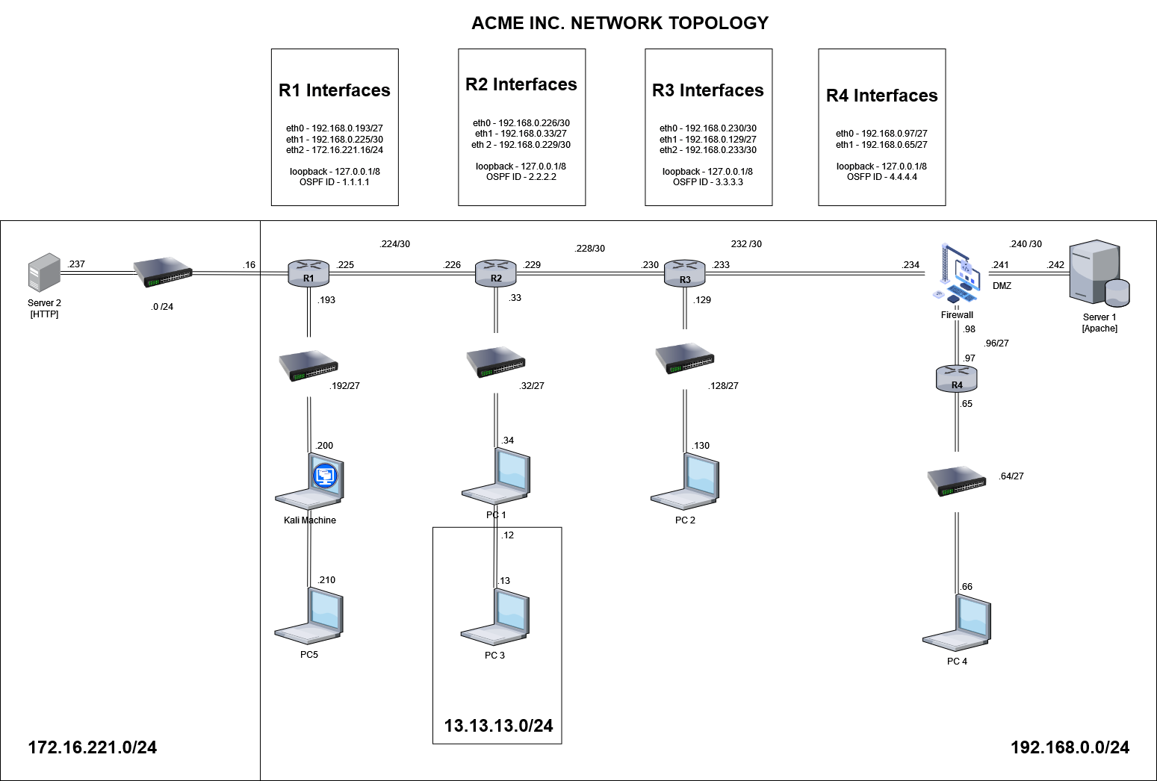

## Network Mapping Process

### Determining Kali interface information

Ifconfig was used to check the running network interfaces on the Kali machine, which gave hints to the range needing to be scanned. The Kali machine had an IP address of 192.168.0.200 and a subnet mask of 255.255.255.224, with the broadcast address being 192.168.0.223. This means that while it is in the 192.168.0.192/27 range, there’s a higher chance of picking up devices if the whole 192.168.0.0/24 network is scanned instead.

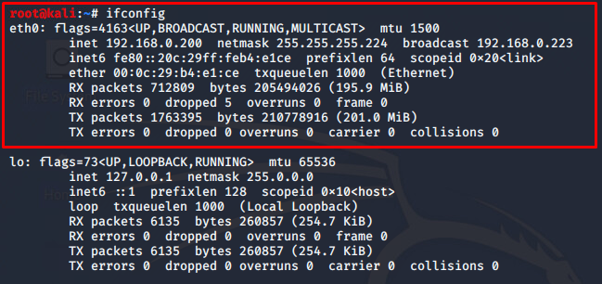

Figure - ifconfig output from Kali

### Scanning for hosts with Netdiscover

Using Netdiscover on the Kali machine to discover hosts was not possible. Performing any sort of scan on the target range (192.168.0.0/24) resulted in an empty results table.

See Appendix A1 for a screenshot of the empty results.

One of the possible reasons for this is that kali uses an experimental version of libpcap (1.9.1) which is known to cause issues with Netdiscover, with the stable releases being 1.8.1-6 and 1.9.1-4 (Samuix, 2019) (dio1911, 2019). Installing new programs on the Kali machine was not permitted by the testing scope, and the machine itself is also not connected to the internet meaning another tool had to be used instead.

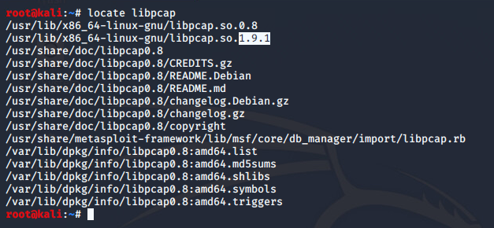

Figure - locating the libpcap version installed

### Scanning for hosts with Nmap

The following Nmap setup was used to scan the IP address range for open ports, with an overview of the options used below:

Nmap -v -sV -sS -O --script=http-headers 192.168.0.0/24 > HTTPoutput.txt

|  |  |
| --- | --- |
| **Option** | **Description** |
| -v | Give verbose results |
| -sV | Probe open ports for service/version info |
| -sS | TCP/SYN scan |
| -O | Probe Operating System version |
| --script=http-headers | If web servers are discovered, probe HTTP headers |
| * HTTPoutput.txt | Pipe results out to a text file |

Table - Nmap options used

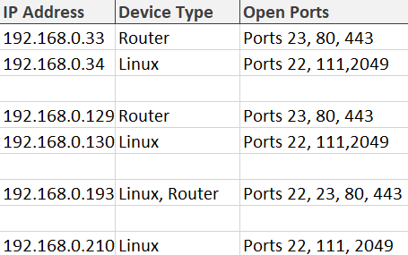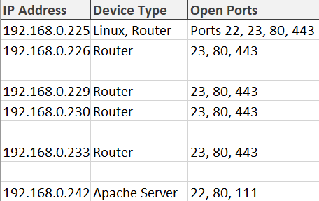From the results, it can be seen that there were a number of different devices available to the attacking machine, notably some routers, PCs, and an Apache server. To discover the remaining devices on the network, vulnerability exploitation had to be used to navigate through them.

Table - Device and open port summary

See Appendix 2A for a summary of the results with port information.

### Password Cracking with Hydra

From Table 2, it can be seen that all the routers visible have their Telnet port open, allowing for remote username and password enumeration, which is vital for gaining administrative privileges and ultimately, discovering the remaining parts of the network.

Hydra was used to enumerate the password for an administrator account, with the username inputs being admin, administrator, and test as these are incredibly common default usernames for devices (DataRecovery, 2014). Once the scan was complete, no relevant passwords were found suggesting it was not in the word list.

See appendix 1B for a screenshot of the results.

### Gaining access to the routers with Telnet

As the routers were VyOS routers, it was worth checking for default credentials. A quick browser search on the home machine hosting the VMs revealed that the default login details are vyos/vyos (Andamasov, 2021).

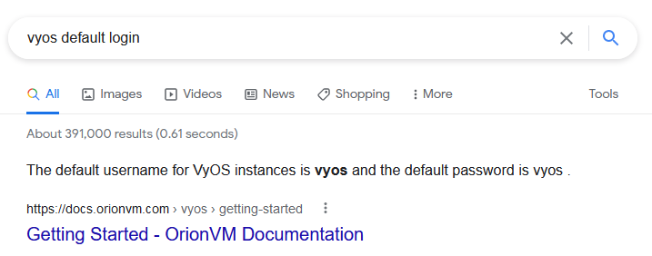

Figure - vyos default login search

Typing them into the Kali telnet prompt results in a successful login, suggesting these default login details were not changed by the network administrator and allowed for unauthorized access to the company’s routers.

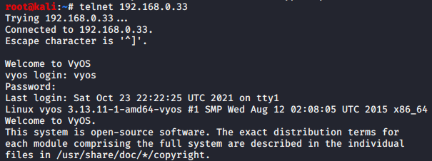

Figure - gaining access to the routers

This was also achieved by using the following Metasploit command, which could open multiple sessions at once. However, Kali’s built-in telnet command worked without any flaws and was used instead.

use auxiliary/scanner/telnet/telnet_login

See Appendix 3A for how the command was used.

### “Show” Command Output Analysis

Analyzing the “Show IP Route” and “Show Interfaces” output of these routers revealed several important points.

* The routers do not use serial cables for router-to-router connections. When listing connections, the only ones that are present are either loopback or ethernet, which would typically make it more difficult to discern which interfaces are between routers and which are between computer networks.

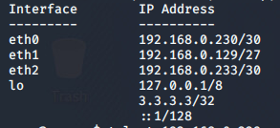

Figure - R3 interface and subnet mask breakdown

* However, the routers use OSPF, which requires each one to have a unique ID (1.1.1.1, 2.2.2.2, etc.). This revealed that Nmap displays interfaces rather than unique devices, as telnetting into different IP addresses revealed duplicate Router IDs, which is not possible in a functional network.

See Appendix 3B for a comparison of results from different interfaces.

* Several discovered networks have a subnet mask of /30, which only allows for two addresses as seen in Figure 5. This subnet mask is most often used for router-to-router connections, with /24 and /27 being reserved for computer networks, giving further hints to the way the networks are connected.

### The 192.168.0.0/24 Network

Knowing the above information allowed for the network structure to be figured out by comparing each router’s output and connecting the relevant interfaces on a diagram. The following screenshot shows the interface output from routers 1.1.1.1, 2.2.2.2, and 3.3.3.3 respectively, the three routers discovered on the current network and their active interfaces.

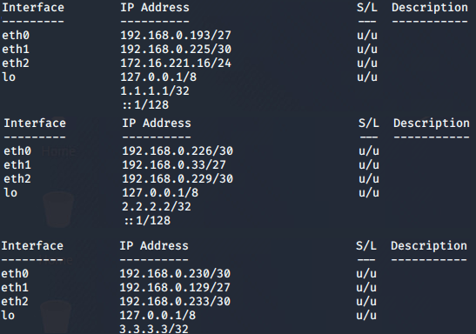

Figure - R1, R2, R3 interface output

Looking at the “Show IP Route” output of these routers showed the various networks they have discovered through either direct connection (C>*) or OSPF discovery (O>*), giving a reliable list of close networks and the interfaces they face.

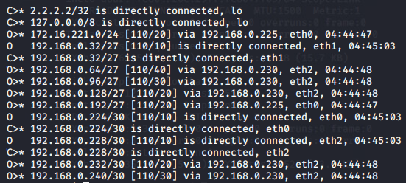

Figure - 'show ip route' output revealing multiple networks that were communicated with

Analyzing Nmap output and the list above allowed the following diagram to be created.

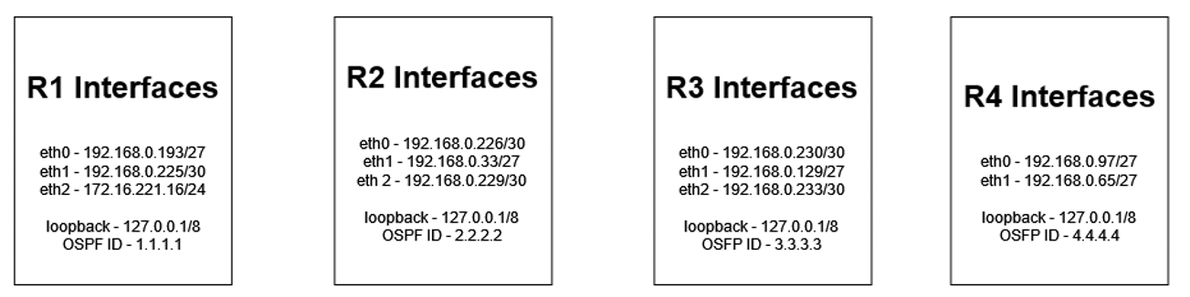

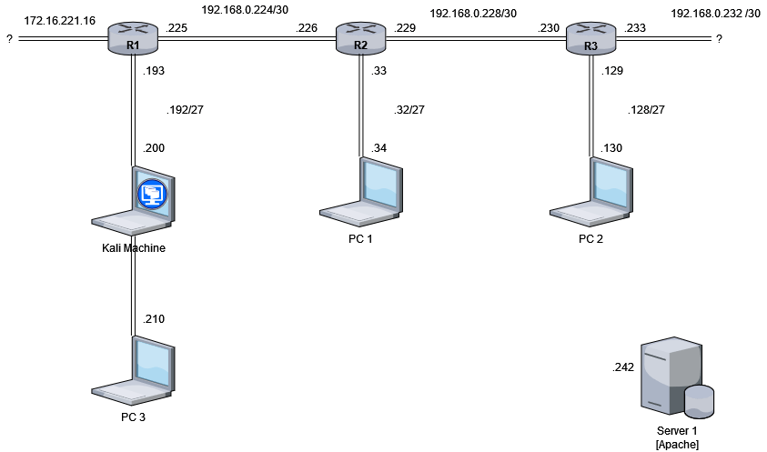

Figure - a map of the network discovered so far

To discover where Server 1 lies on the network, traceroute was used to display each interface network packets take to get to it.

Results showed that packets travel through R1, R2, R3, and then enter another device with the IP address of 192.168.0.234, which can only be a part of the 232/30 network as it includes .233 and .234.

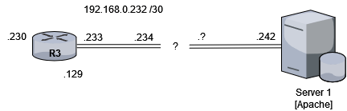

Figure - a map of the devices connected to .234

See Appendix 1C for the full traceroute output.

Pinging the device (.234) resulted in failure and it did not appear on any Nmap scan, suggesting it was set up to block this sort of traffic.

This device and its usage is explored in the section “Beyond the Firewall” on **page XXXXXX**.

Looking at the Nmap results in Table 2 shows that Server 1 had Port 22 open (SSH). This acts similarly to Telnet, which grants access to the shell after a successful login. Performing a Hydra password list scan against this server with the following command revealed the username to be ‘root’ and the password to be ‘apple’ and granted access to valuable information like connected interfaces and usernames, helping to piece together the remaining parts of the network.

See Appendix 1D for the full hydra output showing the found login.

Once logged in, opening /etc/shadow revealed a list of users on the server, with the two main users being ‘root’ and ‘xweb’. These were noted for future Hydra password scans against the other SSH-enabled devices on the network.



Figure - /etc/shadow users

To view the full nano /etc/shadow output, see Appendix 1E

While exploiting the NFS mount port on PC 3 (192.168.0.210), entering /etc/shadow revealed yet another important user account name, xadmin. This was once again added to the list of potential user accounts when scanning for passwords on the remaining devices.

### The 172.16.221.0/24 Network

The 172.16.221.0/24 network is connected via eth2 to R1, as seen in Figure 8. As the initial Nmap scan was performed to only look for devices in the 192.168.0.0/24 range, the devices in 172.16.221.0/24 did not appear, meaning another Nmap scan had to be performed for this network alone.

This revealed the existence of only two interfaces, 172.16.221.16 (the R1 interface found earlier) and 172.16.221.237, an HTTP server that could be browsed to. However, it only displayed a default ‘It works!’ page and has both its telnet and SSH ports closed. There were no other devices found on this network.

See Appendix 1F for all Nmap scan outputs

### The 13.13.13.0/24 Network

While performing Hydra password scans against the remainder of SSH-enabled devices on the network, in this case, PC 1 (192.168.0.34), the username and password were revealed to be ‘xadmin/plums’. This again granted access to information regarding connected interfaces and revealed the existence of a 13.13.13.0/24 network connected to the PC via eth1. The only interfaces present on the network are 13.13.13.12, connected via eth1 to PC 1, and 13.13.13.13, belonging to yet another PC labeled PC 3 on the network diagram. This was discovered by looking through the command history on the device, one of which was ‘ping 13.13.13.13’.

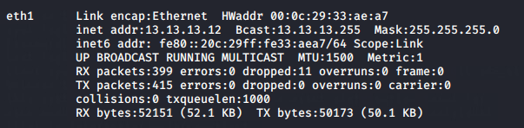

Figure - PC 1 13.13.13.12 interface

To Nmap the 13.13.13.0/24 network to see all active devices and ports, SSH tunneling was utilized to give the kali machine access to that part of the network.

See Creating SSH Tunnels on page 21 to see how this was performed.

Once the tunnel was active, an Nmap scan was performed to see which ports were open. One of these ports was 22 (SSH), but the previous log-in details did not work, meaning another password scan had to be used. Hydra retrieved no valid results with rockyou.txt so Metasploit’s “SSH_login” exploit was used instead with its default password file. The password was found to be “!gatvol”.

See Appendix 1G for the ssh_login options used and the resulting output.

Once logged in, “ifconfig” was used to determine any more connected networks, of which there were none.

### Beyond the Firewall (192.168.0.234)

Since the device was not being picked up by pings or port scans, the first logical step was to gain entry to one of the other devices connected to it. At this point, the only ones available were R3 (via 192.168.0.234) and Server 1 (via 192.168.0.241).

Telnetting into R3 and pinging 192.168.0.234 again revealed nothing, which suggests it is not available to this section of the network. Using telnet or SSH also failed, meaning either these ports were closed, filtered, or the device was dropping any traffic.

However, while logged into Server 1, it was possible to ping either the .234 or .241 interface of the mysterious device, meaning the greatest chance of gaining entry to it was by using the .242 server.

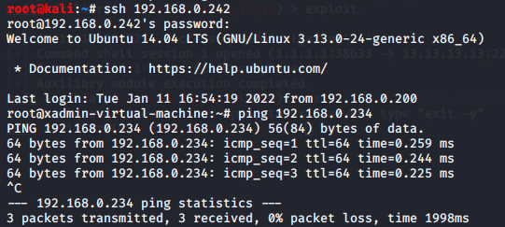

Figure - pinging .234 from server 1

To discover any open ports on the .234 machine, another SSH tunnel had to be set up from the Kali machine, this time to Server 1. This allowed pings to reach .234 and Nmap’s port scan to finally discover its open ports.

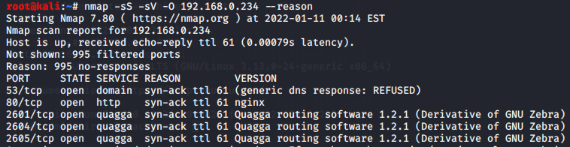

Figure - open ports on .234

The scan revealed the DNS, HTTP, and ‘Quagga TCP’ ports to be open. The first step was to test if any of the ports allow for a telnet entry, of which port 2601 worked. Connecting to telnet displayed a login form as expected, but no previous password worked.

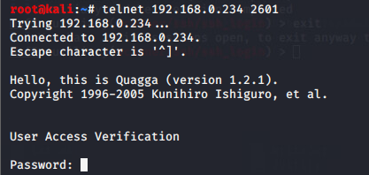

Figure - telnetting into .234

Browsing to 192.168.0.234 directed to a pfsense firewall login page. As the default login credentials for pfsense devices are “admin/pfsense”, inputting “pfsense” into the telnet port granted access to the device’s command line.

From here, the “show interfaces” command was used to display any connected interfaces which had been hidden from the Kali machine and showed that the device was connected to 192.168.0.96/27 via eth0. For Nmap to be able to view the devices on this newly discovered network, however, minor changes had to be made to the firewall’s rules to allow all traffic to flow through it unrestricted.

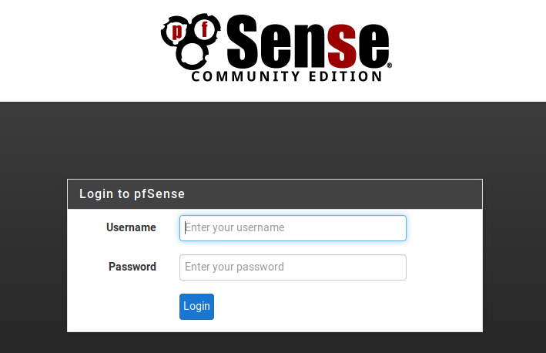

Figure - firewall login page

Having logged in as admin/pfsense and browsing to Firewall >> Rules showed the following screen. For packets to traverse the network freely, the first rule had to be edited with the ‘edit’ action on the right.

The destination option was changed from “single host” to “any”, which allowed Nmap scans to reach the 192.168.0.96/27 network discovered earlier.

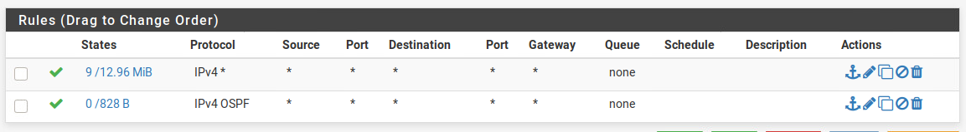

Figure - altered firewall settings

The port scan revealed the .98 interface (connected to the firewall) and another router on the other side, with the IP address 192.168.0.97.

See Appendix 1H for the Nmap scan’s output.

As it was a vyos router, telnetting into it was as easy as entering any of the others discovered previously and was a case of logging in as vyos/vyos. Using ‘show interfaces’ again displayed a new subnet, 192.168.0.65/27, and the OSPF ID for the router which was 4.4.4.4, labeled R4 on the network map.

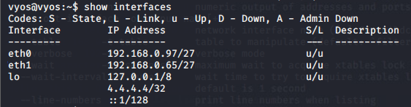

Figure - showing interfaces on the newly discovered router

The only other interface in 192.168.0.64/27 (besides the .65 belonging to the router) was 192.168.0.66, listed as a Linux PC with SSH open.

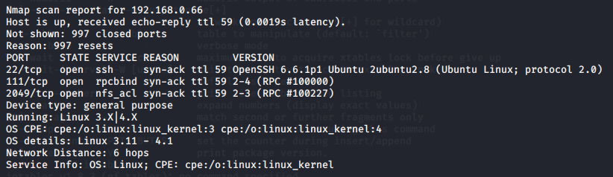

Figure - Nmap results for .66

# Network Security

## Vulnerability Testing Methodology

The methodology used for vulnerability testing was based on the “FRCS Pentest Checklist”, covering a wide variety of attack vectors and access points for vulnerabilities within a network penetration test. Due to scope limitations, some ‘checks’ had to be emitted from the list, for example, checks which require physical access to hardware, Radio Frequency analysis, or attacks that require certain amounts of experience.

|  |  |  |
| --- | --- | --- |
| **Task** | **Description** | **Done?** |
| Network Protocol Traffic Capture | Obtain sample communications on the network | Y |
| Network Protocol Cryptographic Analysis | Identify negotiated cryptographic algorithm | Y |
| Unknown Protocol Decoding | If traffic uses an unknown protocol, reverse engineer the network packets | Y |
| DNS Interrogation | Attempt zone transfers and queries from DNS servers | Y |
| Port Scanning | Scan for open ports with TCP/UDP scanners | Y |
| SNMP Enumeration | Use tools to examine SNMP services | Y |
| Unauthenticated Vulnerability Scanning | Use automated scanners without credentials to scan for vulnerabilities | Y |
| Functional Analysis | Explore the service from a typical user’s perspective | Y |
| Authentication and Default Credentials Testing | Test application authentication for guessable passwords and login enumeration, authentication bypass, or weak Captchas. | Y |
| Authorization Testing | Test the application for authorization flaws like path traversal, authorization bypass, and privilege escalation | Y |
| Identify Attack Avenues | Review findings and identify plausible attack vectors. | Y |
| Vulnerability Exploitation | Create proof of concept attacks to demonstrate the risk of the found vulnerabilities | Y |

## Tools

|  |  |
| --- | --- |
| **Tool name** | **Purpose** |
| Kali CMD | Launching software and executing Linux commands |
| Nmap | Scanning for IP addresses and open ports/vulnerabilities |
| Metasploit Framework | Exploiting vulnerabilities and achieving shell. |
| John | Password Decryption |
| Hydra | Password Enumeration |
| WireShark | Capturing network packets |
| OWASP ZAP | Automated scanner for devices and Vulnerabilities |
| Nikto | Automated scanner for devices and Vulnerabilities |
| Sparta | Automated scanner for devices and Vulnerabilities |
| Telnet/SSH | Gaining access to the device’s command line |

## Network Protocol Testing

### Network Protocol Traffic Capture

Capturing packets from the Kali machine using Wireshark revealed that there was very little network activity. As it is impossible to move the machine around the network, only packets traveling through 192.168.0.200 (eth0) were captured on the 192.168.0.192/27 network, which included OSPF ‘Hello’ packets coming from 192.168.0.193 on a 10-second interval and LLDP_Multicast packets coming from the VMware machine at 30-second intervals, both of which are used for acknowledging the existence of certain devices.

See Appendix 1I for the full results.

### Network Protocol Cryptographic Analysis

To test the cryptographic nature of transmitted packets, a test was performed by telnetting into a device and using SSH to connect to another afterward while running Wireshark, later examining the captured packets.

Analyzing SSH packets showed that they were encrypted with ChaCha20-Poly1305, a faster alternative to the popular and effective AES encryption. The password handshake was spread over multiple network packets and there also does not currently exist a way of decrypting ChaCha20-encrypted traffic. A widely used tool to measure entropy quality is “Ent” on Kali, however, installing additional applications on the Kali machine was not permitted, and thus the entropy quality test could not be performed.

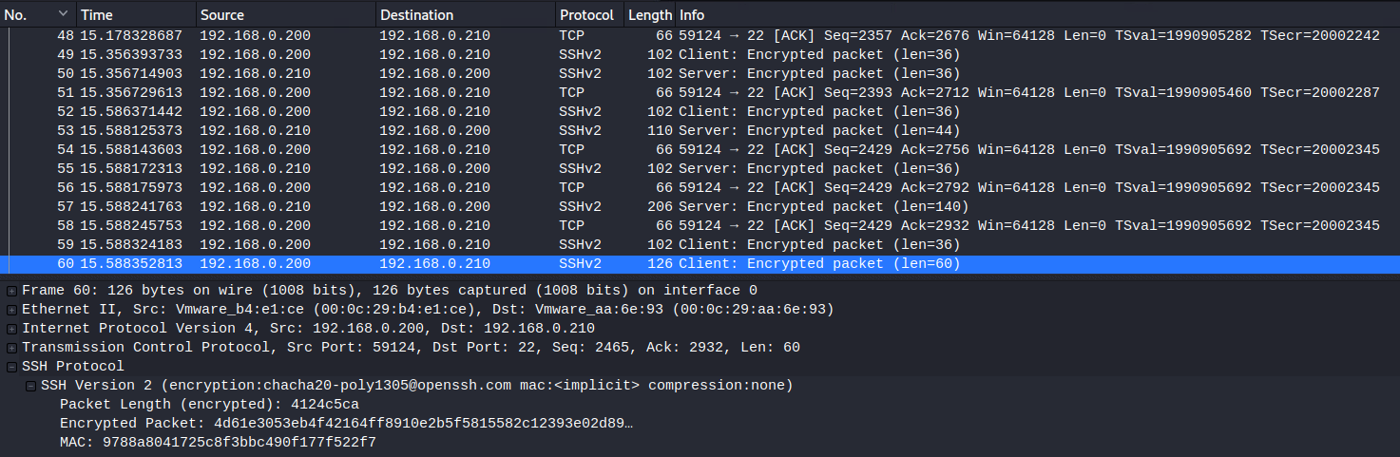

Figure - SSH packet overview

As the routers can only be wirelessly accessed via telnet, all commands and logins were expectedly transmitted in plain text. Each command was separated into its own packet, while logins were separated into packets character by character, slowing down potential attackers but not in a significant manner. These packets can easily be intercepted by a man-in-the-middle attack as shown below.

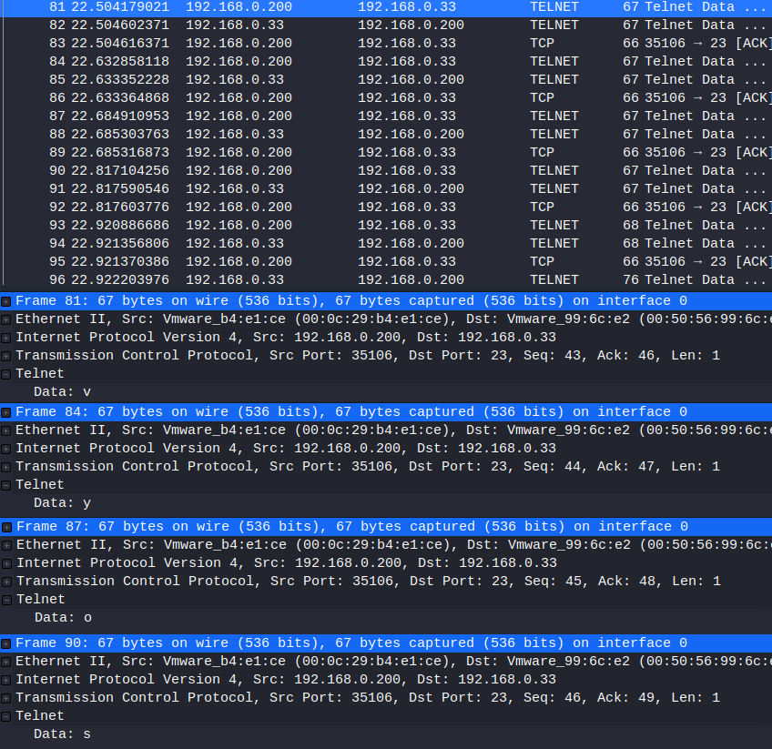

Figure - telnet packet overview

### Unknown Protocol Decoding

All encountered protocols (ARP, LLDP, OSPF, SSH, TCP, and Telnet) were commonly used and standard, with no unknown protocols to decode or analyze.

## Server OS Testing

### DNS Interrogation

Despite the fact the DNS port is opened on the firewall, all connections were refused, and no DNS information was able to be retrieved. This suggested the domain name service was not active anymore, but the port has been left online.

### Port Scanning

The following Nmap command was used to fingerprint open ports and Operating Systems on the network devices in all discovered networks. To maximize the number of devices being found, the networks were scanned as a /24 range, finding all devices in the range from .0 to .254. These scans were performed after setting up SSH tunnels to previously unavailable parts of the network and opening up the firewall to ensure complete results.

nmap -sS -sV -O [ip range]

**192.168.0.0/24**

|  |  |  |
| --- | --- | --- |
| **IP Address** | **Device** | **Open Ports** |
| .33 | R2 | 23 (telnet), 80 (http), 443 (SSL) |
| .34 | PC 1 | 22 (SSH), 111 (rpcbind), 2049 (NFS) |
| .65 | R4 | 23 (telnet), 80 (http), 443 (SSL) |
| .66 | PC 4 | 22 (SSH), 111 (rpcbind), 2049 (NFS) |
| .97 | R4 | 23 (telnet), 80 (http), 443 (SSL) |
| .98 | Firewall | 53 (domain), 80 (HTTP), 2601, 2604, 2605 (Quagga Telnet) |
| .129 | R3 | 23 (telnet), 80 (http), 443 (SSL) |
| .130 | PC 2 | 22 (SSH), 111 (rpcbind), 2049 (NFS) |
| .193 | R1 | 23 (telnet), 80 (http), 443 (SSL) |
| .200 | Kali Machine | 22 (SSH), 3389 (ms-wbt-server RDP) |
| .210 | PC 5 | 22 (SSH), 111 (rpcbind), 2049 (NFS) |
| .225 | R1 | 22 (SSH), 23 (telnet), 80 (http), 443 (SSL) |
| .226 | R2 | 23 (telnet), 80 (http), 443 (SSL) |
| .229 | R2 | 23 (telnet), 80 (http), 443 (SSL) |
| .230 | R3 | 23 (telnet), 80 (http), 443 (SSL) |
| .233 | R3 | 23 (telnet), 80 (http), 443 (SSL) |
| .234 | Firewall | 53 (domain), 80 (HTTP), 2601, 2604, 2605 (Quagga Telnet) |
| .241 | Firewall | 53 (domain), 80 (HTTP), 2601, 2604, 2605 (Quagga Telnet) |
| .242 | Server 1 | 22 (SSH), 80 (HTTP), 111 (rpcbind) |

**13.13.13.0/24**

|  |  |  |
| --- | --- | --- |
| **IP Address** | **Device** | **Open Ports** |
| .12 | PC 1 | 22 (SSH), 111 (rpcbind), 2039 (NFS) |
| .13 | PC 3 | 22 (SSH) |

**172.16.221.0/24**

|  |  |  |
| --- | --- | --- |
| **IP Address** | **Device** | **Open Ports** |
| .16 | R1 | 22 (SSH), 23 (telnet), 80 (http), 443 (SSL) |
| .237 | Server 2 | 80 (HTTP), 443 (SSL) |

See full network scan results in Appendix 1F.

### SNMP Enumeration

Looking at previous port scans reveals there were no SNMP-enabled devices on the ACME INC. network.

### Unauthenticated Vulnerability Scanning

**Owasp ZAP**

Owasp ZAP’s automated spidering was used to view files and pages present on a specific website. In this case, R1, Server 1, Server 2, and the firewall were spidered through and actively scanned for vulnerabilities afterward as they were the only devices with any sort of web page functionality.

192.168.0.242 (Server 1)

Application Error Disclosure, Directory Browsing, X-Frame-Options Header Not Set, Web Browser XSS Protection Not Enabled, X-Content-Type-Options Header Missing.

192.168.0.234 (Firewall)

Multiple X-Frame-Options Header Entries, Absence of Anti-CSRF Tokens, Private IP Disclosure, Web Browser XSS Protection Not Enabled, X-Content-Type-Options Header Missing

192.168.0.193 (R1)

Application Error Disclosure, Directory Browsing, X-Frame-Options Header Not Set, Web Browser XSS Protection Not Enabled, X-Content-Type-Options Header Missing.

172.16.221.237 (Server 2)

X-Frame-Options Header Not Set, Web Browser XSS Protection Not Enabled, X-Content-Type-Options Header Missing.

Findings

The biggest finding here was Private IP Disclosure, where for some reason, one of the firewall’s HTTP Response headers contained the following IP Addresses.

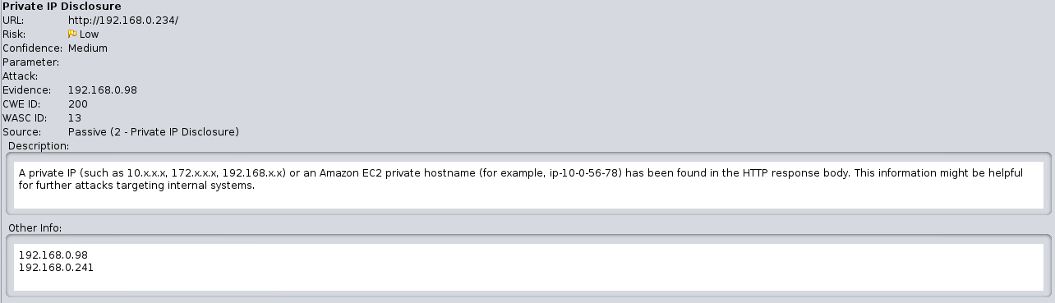

The reason lots of content related to XSS is flagged is because the sites do not have any input boxes, and their general setup is very barebones. Hence, there was no need to set up these flags when putting the network together and they appear as vulnerabilities.

**Nikto**

Using Nikto’s “nikto -h” command to scan the servers on the network revealed the following.

192.168.0.242 - The site appears to be vulnerable to ‘shellshock’ and uses an outdated version of Apache.

192.168.0.234 - Site contains /xmlrpc.php and /help.php, default files which may contain useful information.

172.16.221.237 - The site uses an outdated version of Apache and contains default files and file locations.

See Appendix 1J for a list of all Nikto results.

### Functional Analysis

A typical user on the network would not be accessing any server or router logins as these actions are typically restricted to be utilized only by the networking team. Staff most likely would not use any device other than their own computer. However, the nature of default and simple credentials being used across the network raises the possibility of an insider threat, for example, a disgruntled employee logging into the routers or firewall as those credentials were easy to search for online.

### Default Configuration Testing

As seen in “Unauthenticated Vulnerability Scanning”, The firewall and Server 2 both contained a variety of default files and folders (xmlrpc.php, possibly open to xmlrpc exploits, and help.php), suggesting they were not deleted before the devices first went online. Several HTTP headers were also not defined like the XSS Protection Header, which leaves servers open to Cross-Site Scripting, X-Content-Type which allows users to render site content in unauthorized ways, and the anti-clickjacking X-Frame-Options header was missing too. Accessing the default files, however, resulted in no exploitable information.

See Appendix 1J for the full list of vulnerabilities found by Nikto.

### Authentication and Default Credentials Testing

Telnetting into the routers on the ACME INC. network immediately showed a prompt for VyOS, an open-source routing platform. Searching for default credentials revealed that they are vyos/vyos, and typing them into the telnet prompt allowed for immediate access to the routers and their configuration. This suggests the credentials were not changed from the default.

See Figure 3 for the default login details as seen in a browser search.

This also applies to the firewall, which, when browsed to on any web browser, shows that the firewall is powered by pfsense and prompts the user for a log-in. The default credentials were also not changed on this device, as using admin/pfsense allows users in without any further checks. Accessing the firewall via telnet port 2061 opens up a similar terminal to the routers found previously, and accepts admin/pfsense as a log-in as well, again not having been changed from the defaults.

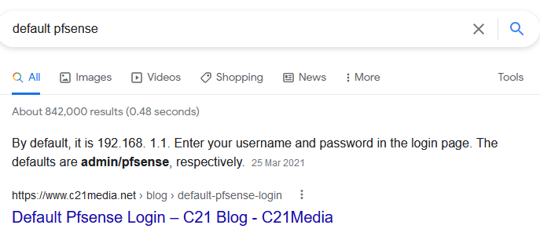

Figure - searching for default pfsense credentials

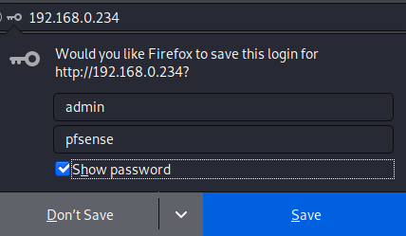

Figure - logging in successfully using default pfsense credentials

### Authorization Testing

In devices with an xadmin login, root escalation could easily be performed after enumerating the xadmin password.

Once logged in as xadmin, navigating to /etc/ssh/sshd_config and changing the “PermitRootLogin” status to “yes” allows the root account to be activated. This allows the “passwd root” command to be used by xadmin, where a new password can be set to the root account, and in turn, allow an attacker to log in as root.

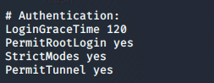

Figure - contents of the sshd_config file

### Identify Attack Avenues

* Default/Simple credentials: Routers, Servers, PCs, Firewall.
* Routers: Plaintext login information gets sent across the network when using Telnet.
* SSH-enabled devices: Open to SSH_login password enumeration, gaining access to other parts of the network via SSH Tunneling and Proxychains,
* NFS-enabled devices: Gaining access to the mount from Kali, finding /etc/shadow.
* Server 1: Shellshock vulnerability
* RPCbind-enabled devices: RPCbomb (DDoS), rpcxml.php
* Browsing default files (.234/xmlrpc and .234/help.PHP)

## Further Vulnerability Exploitation

### Creating SSH tunnels

To perform this exploit, the xadmin password had to have been enumerated (Appendix 1G) and the root user must have been enabled in /etc/ssh/sshd_config and had its password set.

The first step was to SSH into a machine with access to the network which was inaccessible to Kali. For example, the firewall (192.168.0.234/192.168.0.241) or PC 3 (13.13.13.13). Once logged in, the etc/ssh/sshd_config file was located again, this time to add a new line under “#Authentication” which was “PermitTunnel yes”. This allowed the device to handle tunnels from Kali.



Figure - adding tunnel permissions

The SSH service was then restarted with the following command to enable the changes made to the sshd_config file.

service ssh restart

Then, the SSH session was exited out of to SSH in again and use the following commands.

ssh -w0:0 root@192.168.0.242

ip addr add 1.1.1.2/30 dev tun0

ip link set tun0 up

A separate terminal was opened in Kali to perform the same commands to connect the other end of the tunnel.

ip addr add 1.1.1.1/30 dev tun0

ip link set tun0 up

At this point, it was possible to ping from both ends of the tunnel, but it was necessary to enable port forwarding on the remote machine for the Kali machine to be able to connect fully.

echo 1 > /proc/sys/net/ipv4/conf/all/forwarding

Going back to the Kali terminal and using the following command now allows pings and Nmap scans to connect with the previously hidden firewall.

route add -net 192.168.0.242/27 tun0

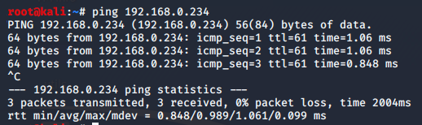

Figure - pings connecting to the firewall

### SSH Proxychains

A quicker way of accessing the firewall login page is through the use of Proxychains, which similarly route traffic through another device to reach a hidden destination (Li, 2020). The first step was to navigate to /etc/proxychains.config and ensure the following line exists at the bottom of the file.

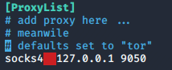

Figure - localhost proxychain

The following command was then used to begin the proxychain service to 192.168.0.234, using the localhost and port information taken from the config file:

proxychains -D 127.0.0.1:9050 192.168.0.234

A separate Kali terminal was then opened to connect to the specified IP address via a selected browser. Navigating to 192.168.0.234 in the browser now showed the pfsense firewall login.

proxychains firefox

### Accessing the NFS mount

Using 192.168.0.210 as an example, its open NFS port was able to be exploited to dump a list of usernames and password hashes (Singh, 2021). To display the mount available to Kali, this command was used.

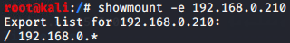

Figure - showing available mounts to kali

This revealed the available directory to be /, which could be navigated for usernames and passwords like mentioned previously. To mount and navigate the NFS directory taken from 192.168.0.210, the following commands have been used. First, to create a directory for the mount to sit in, then to mount it, and display whether it was mounted.

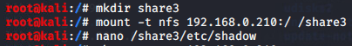

Figure - creating and mounting the directory

using the following command allows access to the list of users on the system:

nano /etc/shadow

navigating to the file revealed xadmin, a vital account for gaining root on systems through privilege escalation on many systems across the network, and their passwords were enumerated using Metasploit’s SSH_login module shown in Appendix 1G.

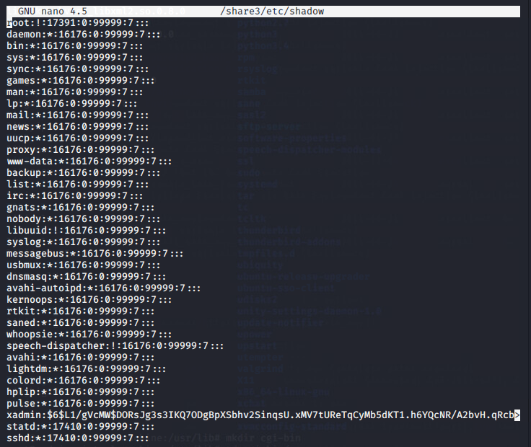

### Shellshock

For shellshock to work, a bash script must be present in the /usr/lib/cgi-bin directory on the target server (DRD_, 2018). However, this directory does not exist on the 192.168.0.242 target server, and even creating it with root privileges did not allow any sort of access through the web browser as it should have done. This was likely a false positive from the scanner, but preventative measures should be undertaken regardless.

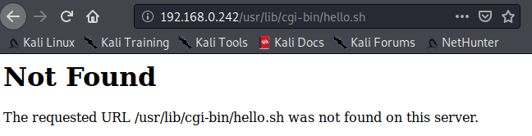

Figure - unable to access a created script from the browser

### RPC Exploits

xmlrpc.php - Attempting to use the wordpress_xmlrpc_login module on Metasploit resulted in the following error, regardless of whether Nikto said the file existed or not on the device. This again means the result was likely a false positive.

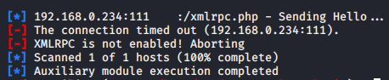

Figure - xmlrpc.php exploit fails despite xmlrpc.php existing on the device according to nikto

RPCbomb - Extra caution was taken when performing this exploit as to not damage the network. A snapshot was taken before executing the rpcbomb module such that the target machine does not crash, and the command was interrupted not long after exploitation just to prove the command did not run into any issues during execution, which it did not.

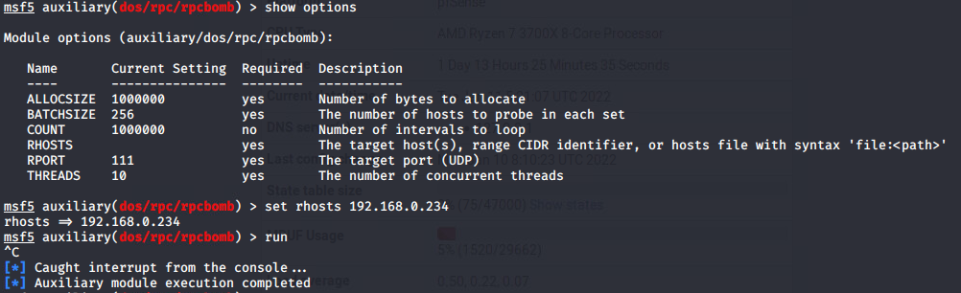

Figure - rpcbomb being run

# Conclusion

## Countermeasures

### Plaintext Logins through Telnet

* Encrypt the traffic around the network using IPSEC, which should encrypt the traffic traveling from the PC to any router. (Cloudflare, 2021)
* Enable SSH/SSL encryption on routers if possible.
* Close the Telnet port on routers and only maintain them through the use of console cables, such that maintenance traffic is not traveling across the network.

### Default Credentials

* Change all default user account names and passwords (For example, vyos/vyos for the routers and admin/pfsense for the firewall). Otherwise, the company runs a risk of an attack or insider thread simply searching for default credentials of any device on the network they are aware of and attempting to get in. Stick to a secure password policy when changing these credentials.

### Open Ports

* Close all unnecessary ports across all the devices on the ACME INC. network. In particular, make sure to check that any internet-facing devices do not advertise unnecessary ports.

### Simple Passwords

* Create a password rule for employees to use, for example, usernames and passwords must not be in the top 10,000 most common credentials. Passwords should also be at least 8 characters in length, use a variety of lowercase and uppercase letters, numbers, and symbols. This can be enforced by creating a password policy on any modern network server. (CARA Technology, 2019)

### SSH

* SSH logins should use public keys, not just passwords. This is present on some of the PCs around the network and should be enforced around the network as well as it makes it much harder for attackers to connect to devices via SSH.

### Shellshock

* Keep bash updated to the latest version, update the device and all its tools/applications as often as possible to prevent Zero-Day attacks as well. (Gonsalves, 2014)

### NFS

* Change the allowed directory into one which cannot be navigated through in a way where attackers may discover sensitive information, particularly not being able to access /etc/shadow or /ssh/sshd_config.
* Place appropriate restrictions on who can view or edit the NFS shares
* Block NFS from outside access

### HTTP Headers

* Multiple X-Frame-Options Headers - Ensure only one X-Frame-Options header is available in a response at one time.
* X-Frame-Options Header Not Set - set the X-Frame-Options header on all pages returned by the site.
* Private IP Disclosure - Remove IP addresses from the HTTP response body.
* XSS Protection Not Enabled - Set X-XSS-Protection HTTP response header to ‘1’, enabling it.
* X-Content-Type-Options Header Missing - Ensure the device sets the Content-Type header correctly and sets the X-Content-Type-Options header to ‘no-sniff’

### Default Files

* Remove all previously mentioned default files and folders from their directories or rename them to something unique that will not be recognized as common or default by scanners.

## Final Conclusion

The network is not fit for public or private use whatsoever. The network’s biggest downfalls are its use of default credentials, which were discovered and exploited quickly even without much particular technical knowledge or experience, to the point where the same could be performed by disgruntled employees in the future, which would greatly risk the company’s security, trust, profits, and future successes. The network also suffers from unnecessarily open ports, particularly on routers with which maintenance over a network must be avoided at all costs. While SSH itself is an encrypted communication protocol, there were too many easy passwords to discover, regardless of whether they were encrypted or not, hence, a password policy must be put in place for all the employees on-site. Public keys should also be utilized more often, not just on a select few devices, to ensure an attacker with a valid username and password cannot enter susceptible devices.

The network structure is also flawed, relying too much on a single line from R1, R2, R3 to R4. Should this line break, devices on the network will not be able to communicate with each other, and this could debilitate the performance of the network and its users greatly. It is highly recommended a set of backup or ‘redundancy’ systems be put in place as soon as possible, or the network topology is changed to something naturally more redundant, like a ring or mesh topology, taking associated costs and problems that may arise into account.

# References

Andamasov, Y., 2021. *VyOS Default User and Password.* [Online]   
Available at: https://support.vyos.io/en/kb/articles/vyos-default-user-and-password  
[Accessed 13 January 2022].

CARA Technology, 2019. *Password Policy Sample.* [Online]   
Available at: https://www.cara.uk.com/wp-content/uploads/2019/11/Password-Policy-Template-CARA.pdf  
[Accessed 13 January 2022].

Cloudflare, 2021. *What is IPSEC?.* [Online]   
Available at: https://www.cloudflare.com/en-gb/learning/network-layer/what-is-ipsec/  
[Accessed 13 January 2022].

DataRecovery, 2014. *Default Passwords.* [Online]   
Available at: https://datarecovery.com/rd/default-passwords/  
[Accessed 13 January 2022].

dio1911, 2019. *Netdiscover not working under Kali 2019.4.* [Online]   
Available at: https://forums.kali.org/archive/index.php/t-45949.html  
[Accessed 13 January 2022].

DRD_, 2018. *Exploit Shellshock on a Web Server Using Metasploit.* [Online]   
Available at: https://null-byte.wonderhowto.com/how-to/exploit-shellshock-web-server-using-metasploit-0186084/  
[Accessed 13 January 2022].

Gonsalves, A., 2014. *Six key defenses against Shellshock attacks.* [Online]   
Available at: https://www.csoonline.com/article/2689294/six-key-defenses-against-shellshock-attacks.html  
[Accessed 13 January 2022].

Li, V., 2020. *Proxying Like a Pro: Using ProxyChains to Proxy Your Internet Traffic.* [Online]   
Available at: https://medium.com/swlh/proxying-like-a-pro-cccdc177b081  
[Accessed 13 January 2022].

Samuix, 2019. *[HOWTO] Fix netdiscover not working properly on Kali 2020.1.* [Online]   
Available at: https://samiux.blogspot.com/2020/03/howto-fix-netdiscover-not-working.html  
[Accessed 13 January 2022].

Singh, S., 2021. *Exploiting NFS share [updated 2021].* [Online]   
Available at: https://resources.infosecinstitute.com/topic/exploiting-nfs-share/  
[Accessed 13 January 2022].

# Appendices

## Appendix 1 - Output

### 1A - Empty results table from Netdiscover

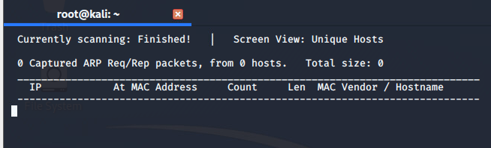

### 1B - Hydra output (Failed scan)

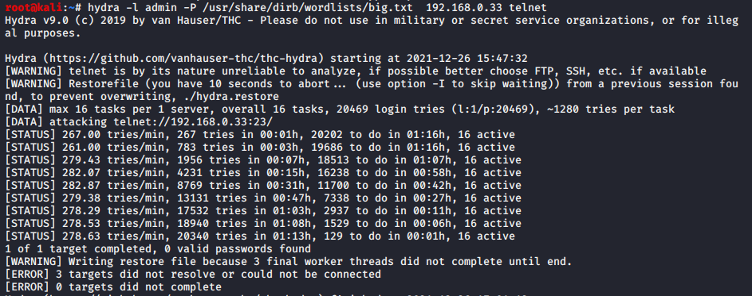

### 1C - Traceroute to .242

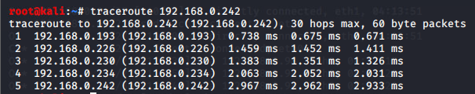

### 1D - Hydra output - login discovered

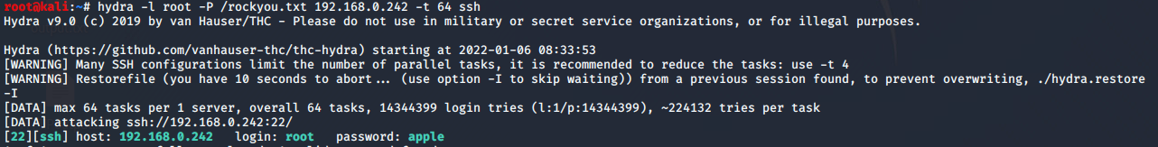

### 1E - 192.168.0.242 users + hashes

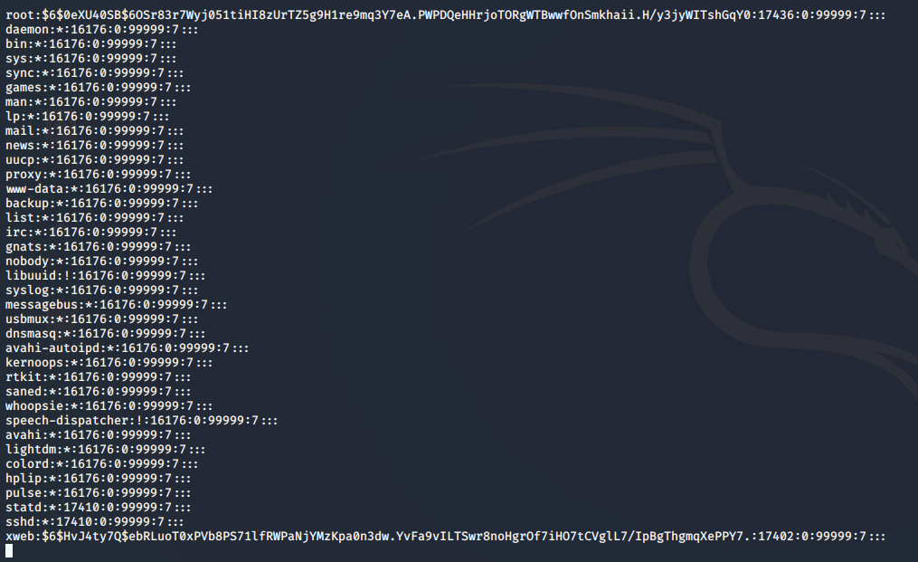

### 1F - Nmap results from all networks (192.168.0.0/24, 172.16.221.0/24, 13.13.13.0/24)

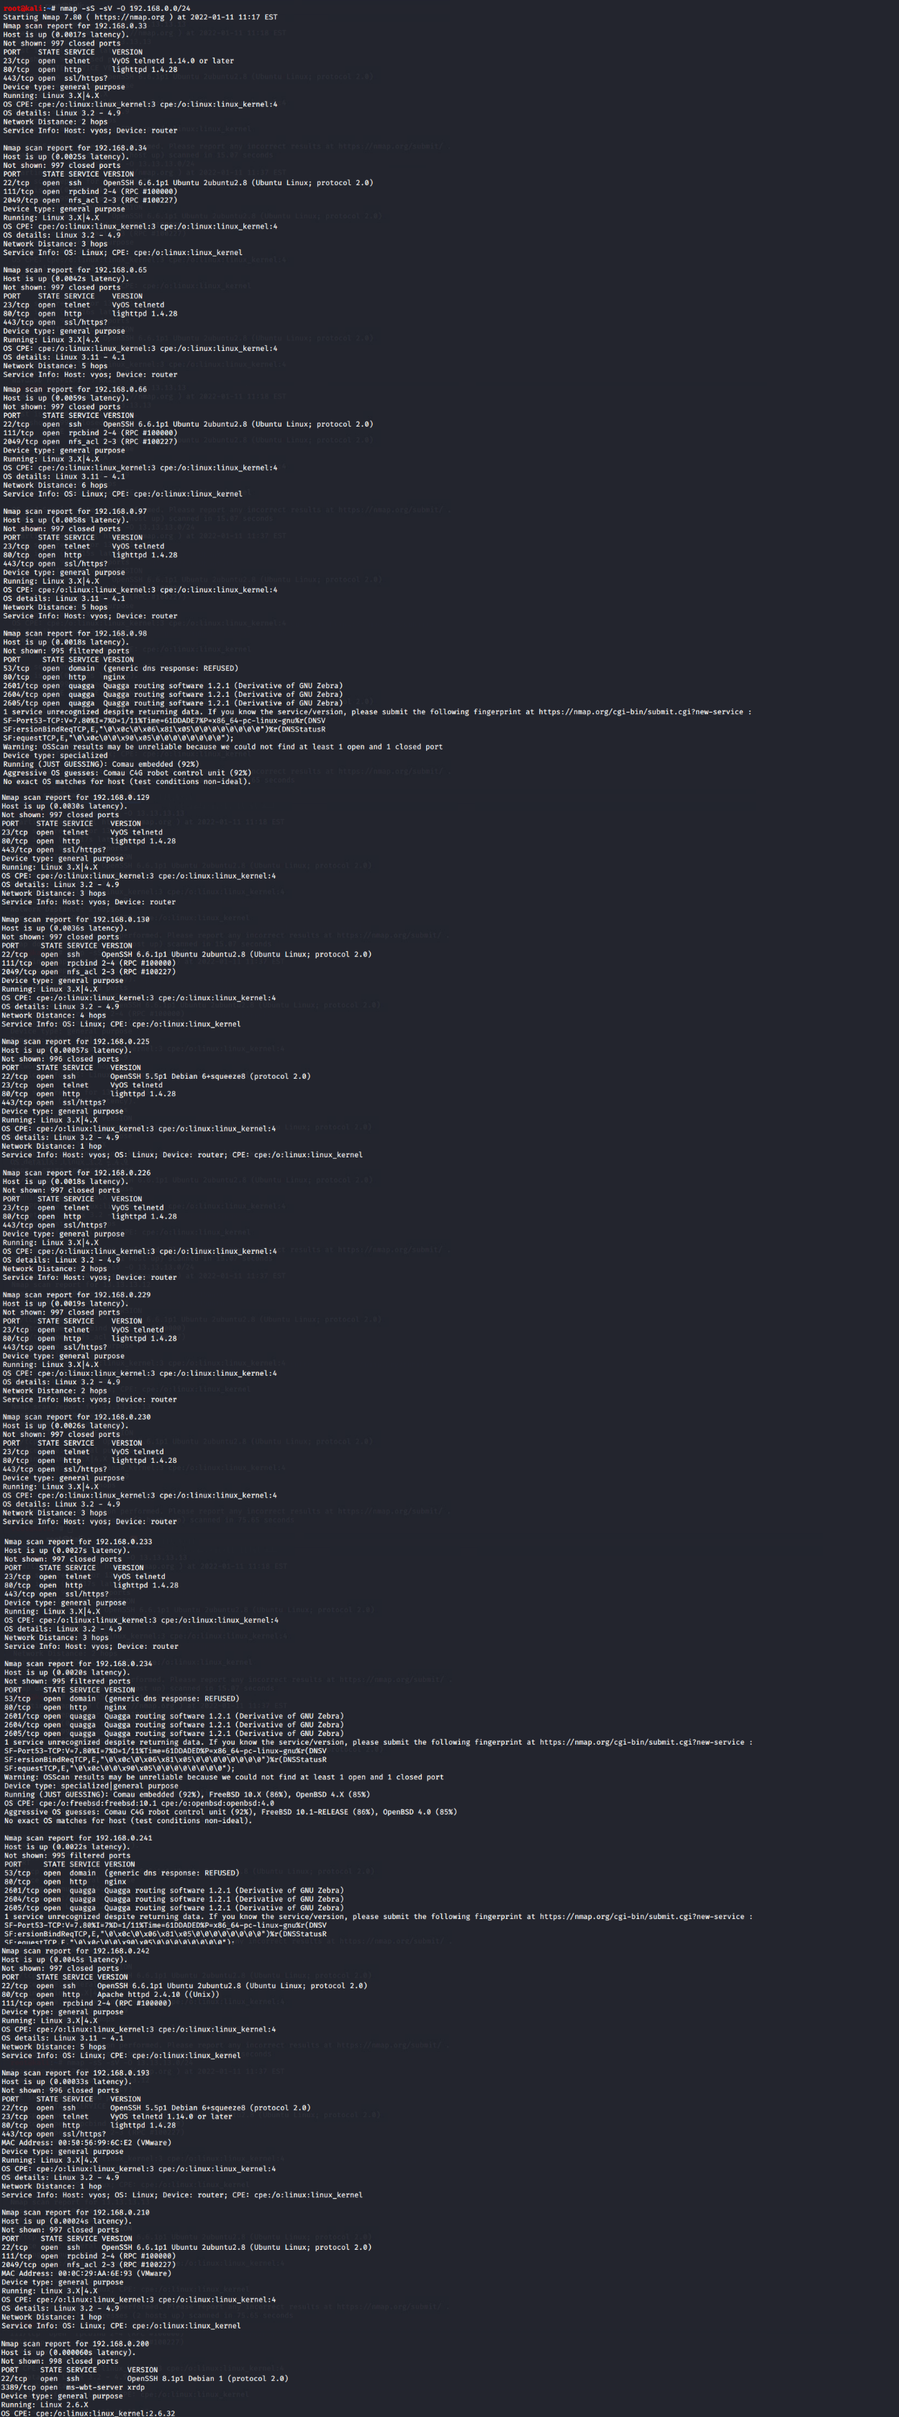

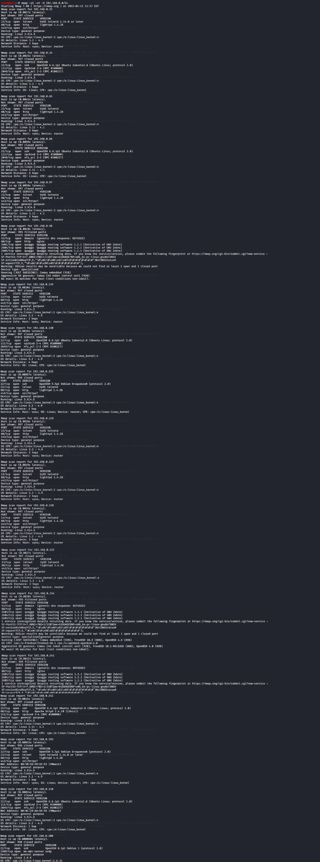

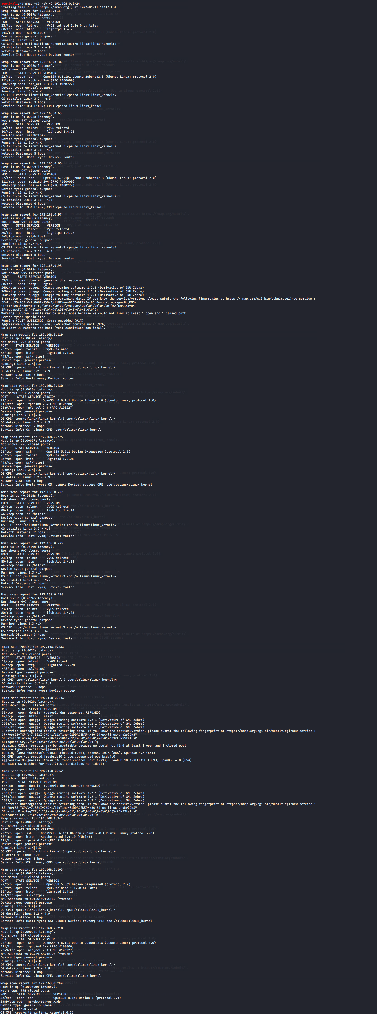

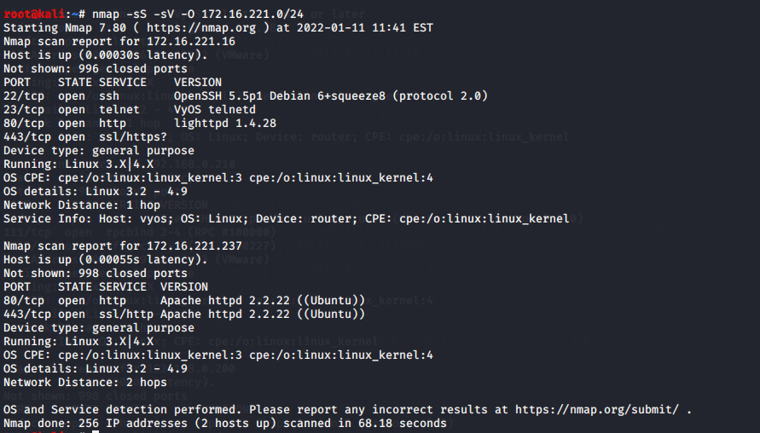

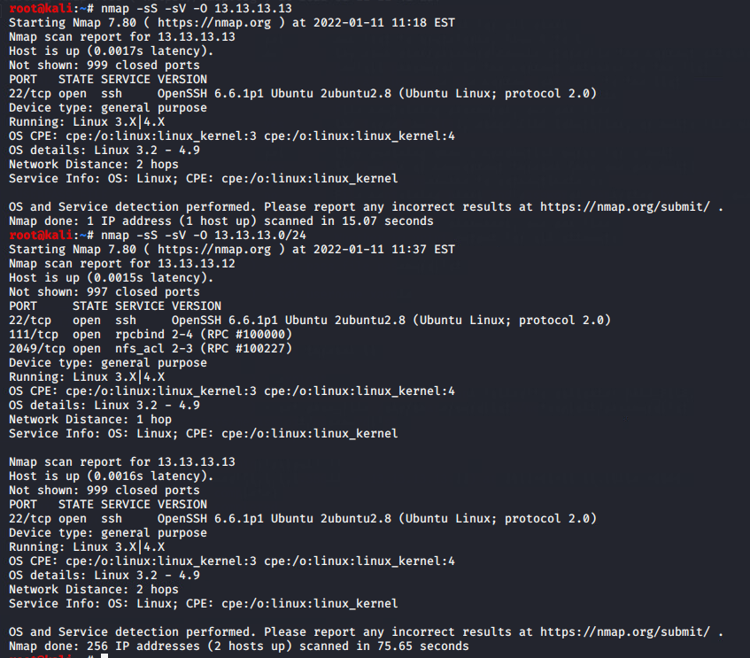

### 1G - SSH_login password enumeration for 13.13.13.13

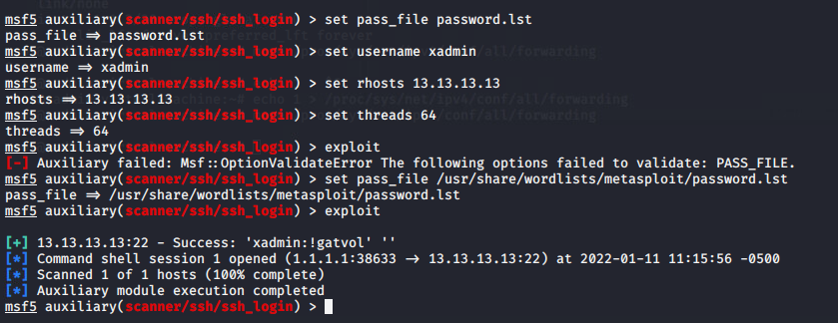

### 1H - Nmap scan output revealing new networks past the firewall

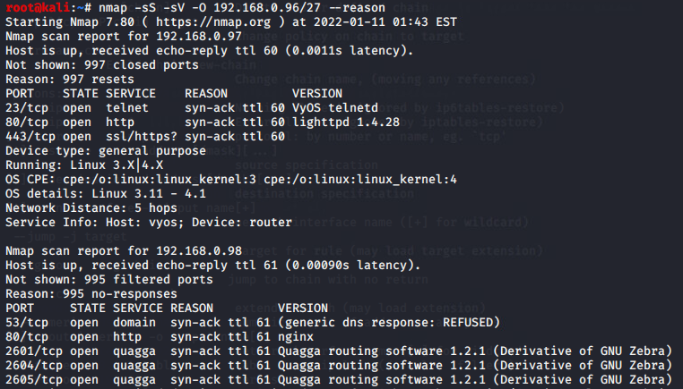

### 1I - Wireshark network activity output

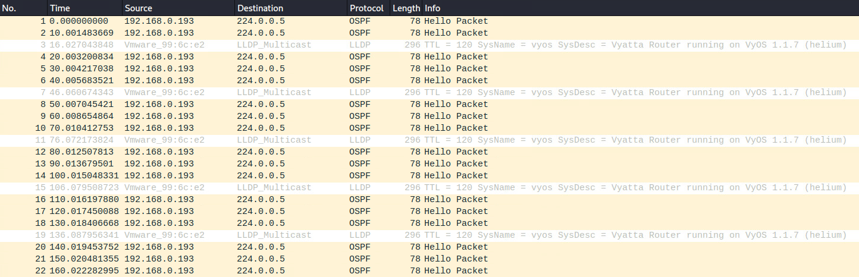

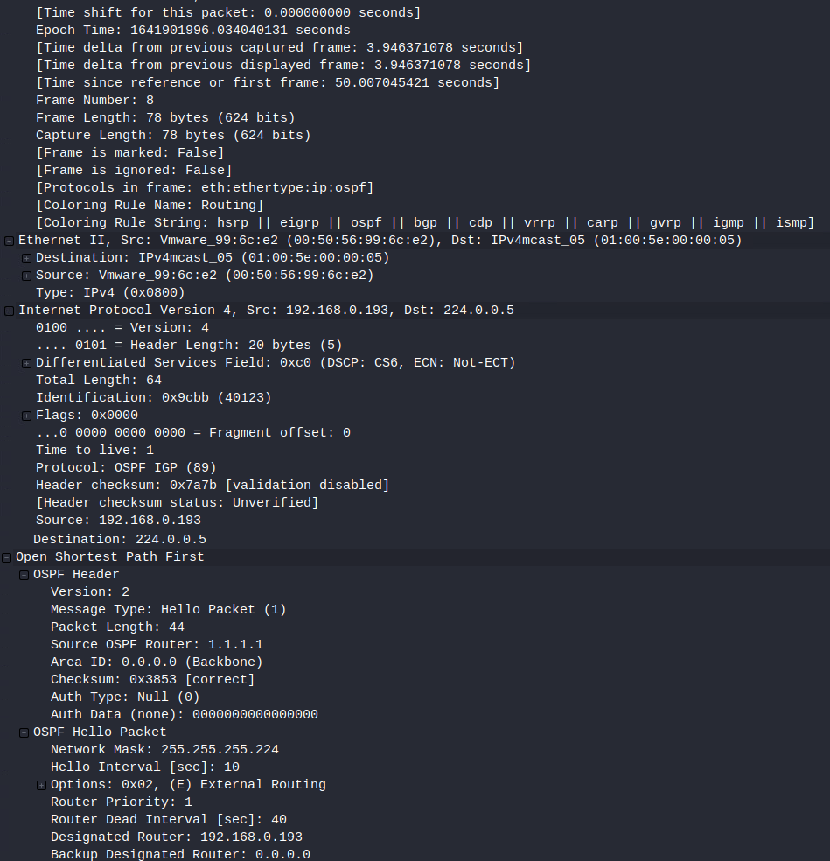

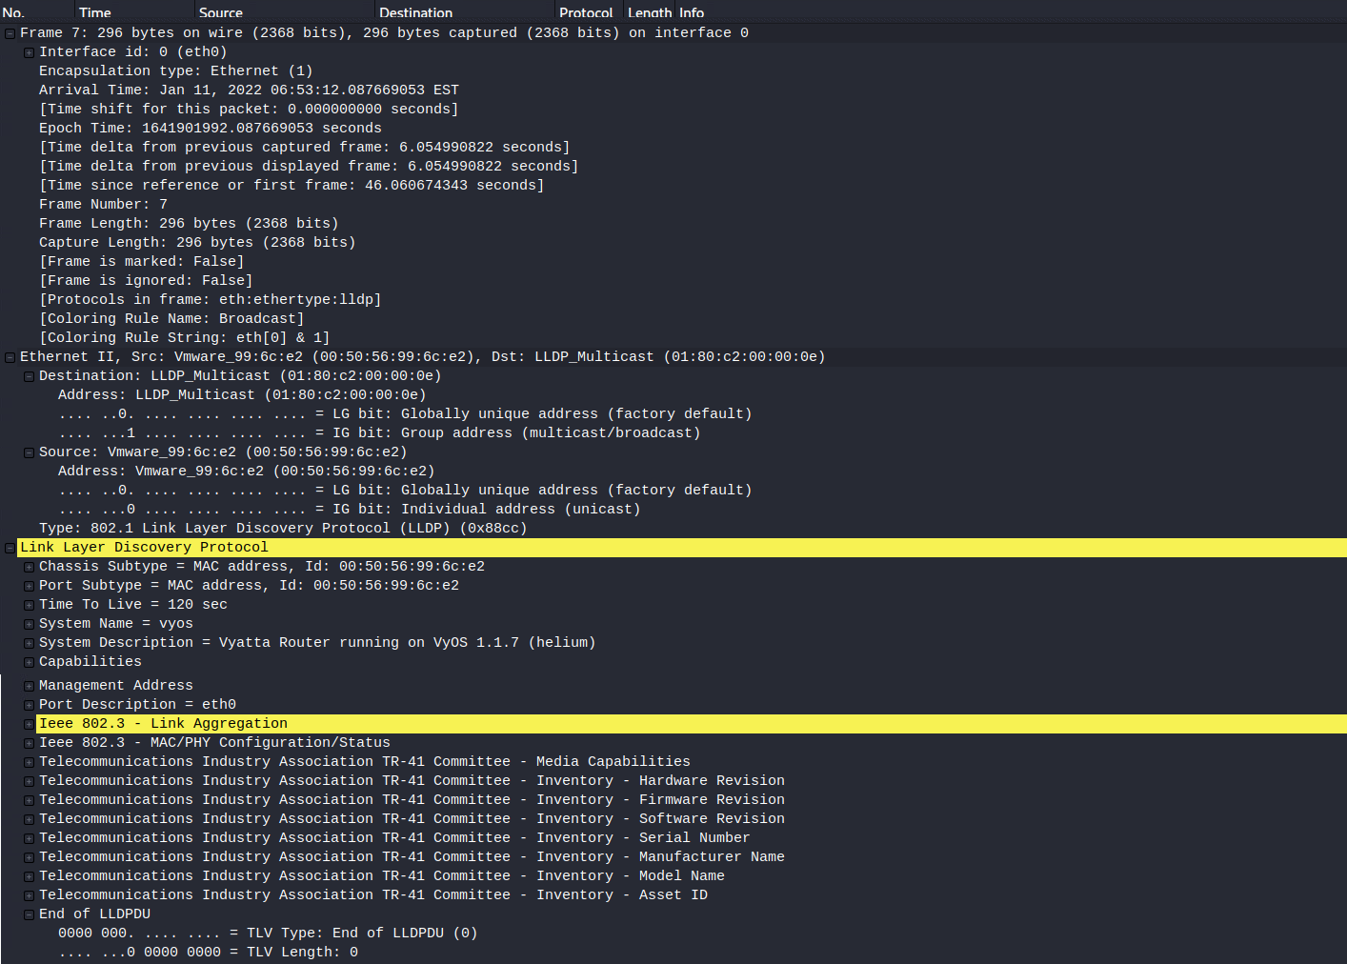

### 1J - Nikto output

.242

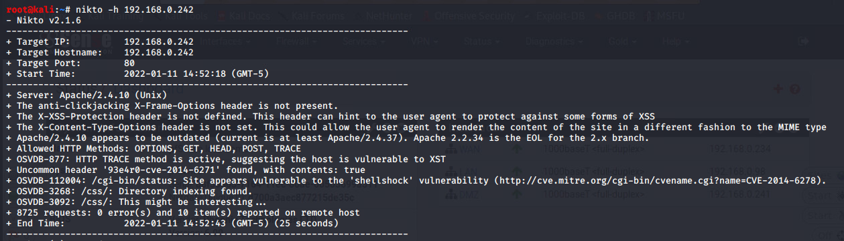

.234

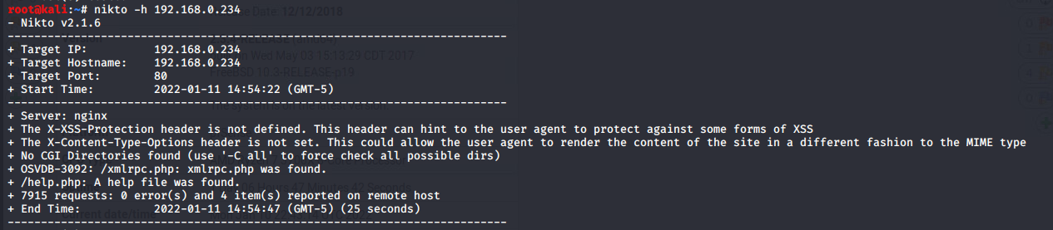

172.16.221.237

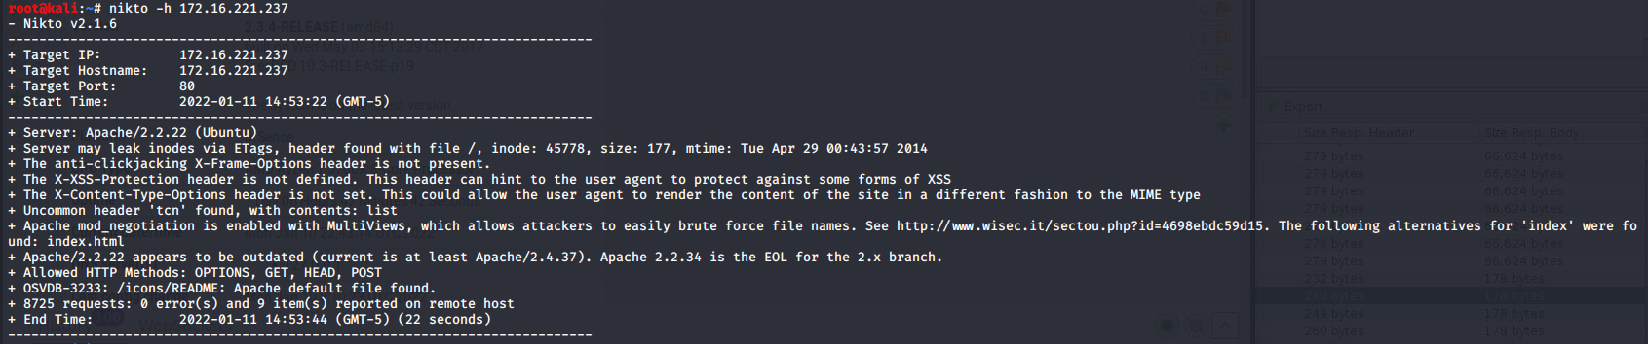

## Appendix 2 - Tables

### 2A - Nmap scan results summary (with port information)

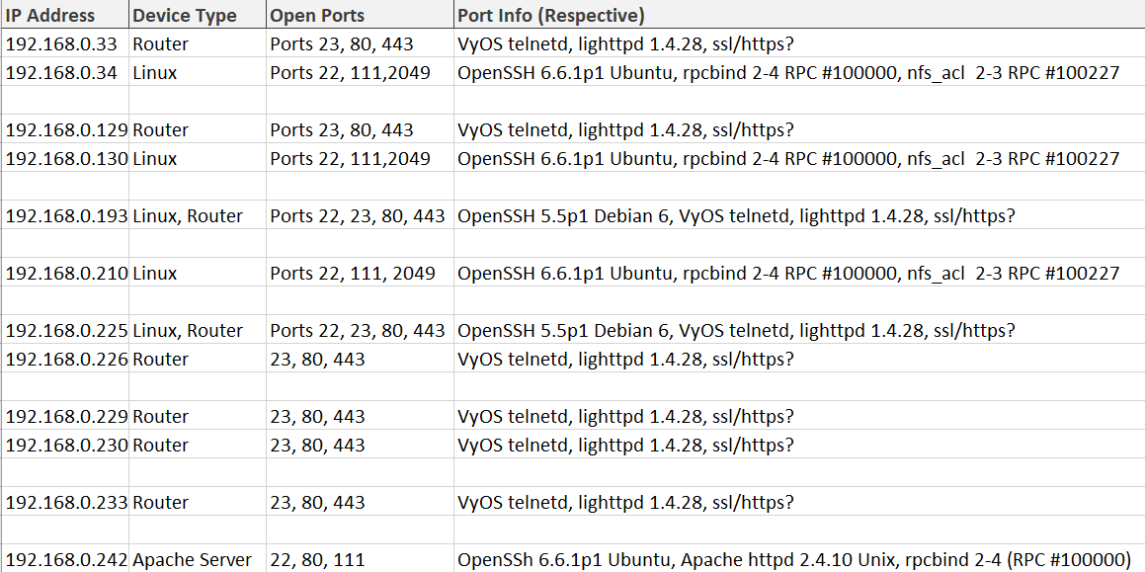

## Appendix 3 - Miscellaneous

### 3A - Metasploit Telnet

The module required a target network, username file, and a password file to function.

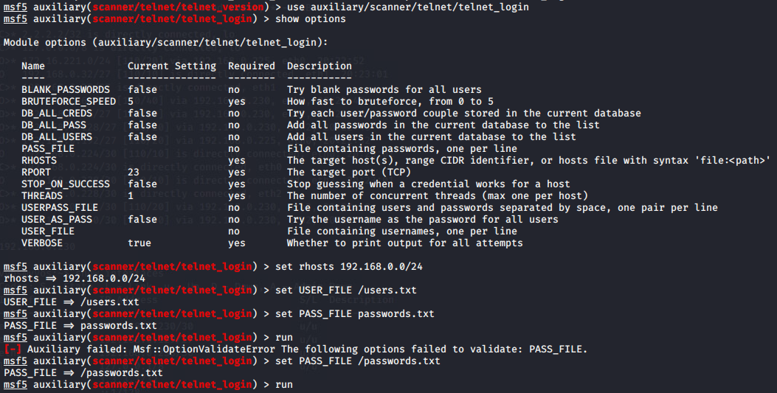

Later versions allow for a single username and password combination to be used without the need to create separate files, but as updates were not possible, this could not be done. Since the username and password for the routers were already figured out, all that was needed to be done was to write a text file someplace containing ‘vyos’ for the exploit to read in. In this case, the files ‘username.txt’ and ‘password.txt’ were created in the “/” directory for easy access.

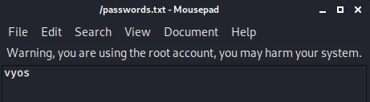

The exploit was then run and produced the following results, successfully gaining access to the routers discovered during the first Nmap scan.

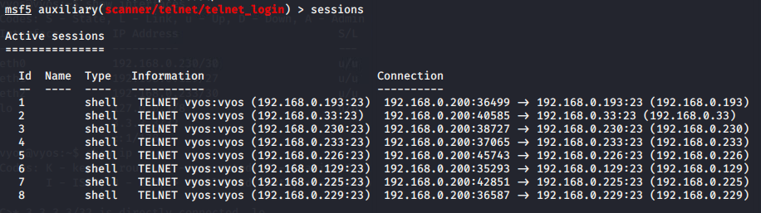

To interact with the sessions and enter the vyos router screen, the following command was used, where -i means interact followed by the corresponding session ID.

sessions -i 1

### 3B - Going through different interfaces on a router

